

JAVA PROJECT REPORT ON
SUPERMARKET CHECKOUT AND DISCOUNT BILLING SYSTEM

Submitted by
KALIMUTHU.M
25BCS223

Under the Guidance of
DHARNEESH
Technical Trainer
Technical Department, KG College of Arts and Science

Academic Year: 2025 – 2026
APRIL 2026
Semester: II

DECLARATION
I hereby declare that the project entitled “SUPERMARKET CHECKOUT AND DISCOUNT BILLING SYSTEM” submitted in partial fulfillment of the requirements for the course JAVA PROGRAMMING is a record of my original work carried out under the guidance of DHARNEESH , Technical Trainer, Technical Department, KG College of Arts and Science.
I further declare that this project has not been submitted previously, either in part or in full, for the award of any degree, diploma, or other similar title, at this or any other institution.
I have acknowledged all sources of information used in this project wherever applicable.

April 2026
Coimbatore

________________________
KALIMUTHU.M

CERTIFICATE
This is to certify that the project entitled “SUPERMARKET CHECKOUT AND DISCOUNT BILLING SYSTEM” is a bona fide work carried out by KALIMUTHU.M , I ‘C’ , Bsc COMPUTER SCIENCE , KG College of Arts & Science, in partial fulfillment of the requirements for the course JAVA PROGRAMMING.
This project has been completed under my supervision and guidance during the academic period April 2026.

Place:
Date:

Submitted for the Viva-Voce Examination held on __________________________________

Guide: Head of the Department
(Technical Trainer, KGCAS) (Technical Head, KGCAS)

______________________ _______________________

TABLE OF CONTENTS
S. No. | Topics | Page. No.
1 | Introduction
1.1 | Objective
1.2 | Overview
1.3 | Features
2 | Program Analysis
2.1 | Problem Definition
2.2 | Project Overview
2.3 | Scopes and Limitations
3 | System Design
3.1 | Modules
4 | Methodology
4.1 | Problem Analysis
4.2 | System Design
4.3 | Program Development
4.4 | Testing and Validation
4.5 | Result and Documentation
4.6 | Algorithm
4.7 | Flowchart
5 | Source Code
6 | Input and Output Screens
7 | Discussion and Conclusion
7.1 | Discussion
7.2 | Conclusion
8 | References

ABSTRACT
The Supermarket Checkout and Discount Billing System is a Java-based application developed to automate the billing process in supermarkets and retail shops. In many small-scale businesses, billing operations are still performed manually using paper or calculators, which often leads to calculation mistakes, increased waiting time for customers, and poor record maintenance.

This system provides a computerized solution where users can enter product details such as name, price, and quantity. The system automatically calculates the total bill, applies discounts based on predefined conditions, and generates an accurate invoice.

The application is developed using Core Java programming concepts including classes, objects, methods, loops, and conditional statements. The system can be implemented either as a console-based application or extended into a graphical user interface.

The main goal of this project is to improve billing accuracy, reduce manual workload, and provide faster checkout service to customers in supermarkets.

- INTRODUCTION
Billing is one of the most important operations in a supermarket, as it directly affects customer satisfaction and business efficiency. Traditional billing methods involve manual calculations, which are time-consuming and prone to human errors.
With the advancement of technology, automated billing systems have become essential. A computerized system can quickly calculate totals, apply discounts, and generate structured bills.
The Supermarket Checkout and Discount Billing System is designed to simplify the billing process. It allows users to enter multiple items, calculate totals automatically, apply discounts when applicable, and generate a final bill.
This project demonstrates how Java programming can be used to solve real-world problems in business environments.
1.1 Objective
The main objectives of this project are:
- To design and develop a supermarket billing system using Java programming
- To automate the process of calculating the total bill for multiple items
- To reduce human errors that occur during manual calculations
- To implement automatic discount calculation based on billing conditions
- To provide a fast and efficient checkout system for customers
- To generate a clear, well-structured bill including all details
- To demonstrate the use of Core Java concepts such as loops, conditions, and methods
- To improve the overall efficiency of supermarket billing operations

1.2 Overview
The Supermarket Billing System is a menu-driven Java application designed to perform billing operations easily.
- The system allows the user to input multiple products one by one
- For each product, the user enters price and quantity
- The system calculates the total cost of each item automatically
- All item costs are added to generate the subtotal
- A discount is applied if the total exceeds a certain amount
- The final bill is displayed with total, discount, and payable amount
This system reduces manual work and improves billing speed.

1.3 Features
The system includes the following features:
- Product Entry System
° Allows the user to enter product details such as price and quantity
° Supports multiple items in a single bill
- Automatic Bill Calculation
° Calculates total price for each item
° Adds all item totals to generate subtotal
- Discount Application
° Applies discount automatically based on conditions
° Example: 10% discount if total exceeds ₹1000
- Invoice Generation
° Displays item details clearly
° Shows total, discount, and final payable amount
- User-Friendly Interface
° Simple and easy-to-use system
° Suitable for beginners and small shop owners
- Fast Checkout Process
° Reduces waiting time for customers
° Improves overall service efficiency

2. PROGRAM ANALYSIS
Program analysis is an important phase in software development where the problem is studied in detail and the requirements of the system are identified. This phase helps in understanding how the system should function and what features are necessary to solve the problem effectively.
In the case of supermarkets, billing is a critical operation that must be accurate and fast. The analysis phase focuses on identifying the issues in the existing manual billing system and developing a computerized solution to overcome those problems.
2.1 Problem Definition
In many small supermarkets and retail shops, billing is often performed manually using paper or basic calculators. This traditional approach leads to several problems and inefficiencies.
Some of the major problems are:
- Errors in Calculation
Manual billing increases the chances of mistakes in addition, multiplication, and discount calculation, which may lead to incorrect bills.
- Time-Consuming Process
Preparing bills manually takes more time, especially when multiple items are involved, resulting in long waiting time for customers.
- Difficulty in Handling Multiple Items
When customers purchase many products, it becomes difficult to calculate totals quickly and accurately.
- No Automatic Discount System
Discounts must be calculated manually, which may lead to incorrect or inconsistent discount applications.
- Lack of Proper Records
Manual billing does not maintain organized records, making it difficult to track sales and transactions.
- Increased Workload for Staff
Staff must spend more time on calculations instead of focusing on customer service.
Because of these issues, there is a need for an automated billing system that can perform calculations quickly, apply discounts correctly, and generate accurate bills.

2.2 Project Overview
The Supermarket Checkout and Discount Billing System is a Java-based application developed to simplify and automate the billing process in supermarkets.
The system provides the following functionalities:
- Allows the user to enter product details such as price and quantity
- Supports multiple items in a single transaction
- Automatically calculates the total cost of each item
- Computes the subtotal of all items entered
- Applies discount automatically if the total amount exceeds a predefined limit
- Generates a final bill showing total amount, discount, and payable amount
The system is designed as a simple and user-friendly application, making it suitable for small supermarkets and retail shops. It reduces manual effort and ensures accurate billing.
This project is implemented using Core Java programming concepts and demonstrates how programming can be applied to real-world business problems
.2.3 Scopes and Limitations
Scope
The Supermarket Checkout and Discount Billing System can be used in:
- Supermarkets and grocery stores
- Small retail shops
- Departmental stores
- Mini marts and provision stores
The system helps in:
- Fast and accurate billing
- Reducing manual calculation errors
- Improving customer service efficiency
- Simplifying checkout operations
Limitations
Despite its advantages, the system has some limitations:
- No Database Storage
The system does not store billing records permanently.
- Limited Features
Only basic billing and discount calculation are implemented.
- No Barcode Scanning
Product details must be entered manually.
- No Payment Integration
Does not support online or digital payment methods.
- Console-Based Interface
The system may not be visually attractive without GUI implementation.

3. SYSTEM DESIGN
System design is the stage where the structure and components of the system are planned before the actual implementation. In this phase, the system is divided into different modules, and the workflow of the application is clearly defined. Proper system design helps in organizing the program efficiently and makes development easier.
The Supermarket Checkout and Discount Billing System is designed as a simple menu-driven application where users can enter product details, calculate total cost, apply discounts, and generate the final bill.
The system is divided into several modules, each responsible for performing a specific function.
3.1 Modules
The main modules of the Supermarket Checkout and Discount Billing System are explained below:
1. Product Entry Module
This module is responsible for accepting input from the user regarding the products.
Functions of this module include:
- Accepting the number of items to be purchased
- Accepting price of each product
- Accepting quantity of each product
- Storing the input values for further processing
This module acts as the starting point of the billing process. It ensures that all required data is collected from the user.
2. Item Calculation Module
This module calculates the total cost of each individual item.
Functions of this module include:
- Calculating item total using the formula:
Item Total = Price × Quantity
- Displaying the cost of each item
- Passing calculated values to the billing module
This module ensures that each product’s cost is calculated accurately before adding it to the total bill.
3. Billing Module
This module is responsible for calculating the overall bill.
Functions include:
- Adding all item totals to compute subtotal
- Maintaining running total of the bill
- Preparing data for discount calculation
Example:
- If Item1 = ₹200 × 2 = ₹400
- If Item2 = ₹150 × 3 = ₹450
- Subtotal = ₹850
This module plays a key role in generating the complete bill.
4. Discount Module
This module applies discounts based on predefined conditions.
Functions include:
- Checking if total amount exceeds a certain limit
- Applying discount percentage accordingly
Example:
- If total > ₹1000 → 10% discount
- Discount = Total × 10%
This module helps in improving customer satisfaction and encouraging purchases.
5. Final Bill Generation Module
This module generates the final invoice for the customer.
The bill includes:
- Total amount before discount
- Discount amount
- Final payable amount
Example Output:
------ SUPERMARKET BILL ------

Total Amount : 1100
Discount (10%) : 110
Final Amount : 990

Thank You! Visit Again!
This module ensures that the output is clear, structured, and easy to understand.
6. Exit Module
This module allows the user to terminate the application safely.
Functions include:
- Ending the program execution
- Releasing system resources
This ensures that the system closes properly after billing is completed.

4. METHODOLOGY
Methodology describes the process followed to develop the project. It explains the steps taken from understanding the problem to designing, implementing, testing, and documenting the system.
For the Supermarket Checkout and Discount Billing System, a structured development approach was followed to ensure that the system meets the requirements and performs efficiently.
The development process includes the following stages:
• Problem Analysis
• System Design
• Program Development
• Testing and Validation
• Result and Documentation

4.1. Problem Analysis
In this phase, the problem is studied carefully to understand the issues in the existing system and to identify the requirements for the new system.
The main problems identified in manual billing systems are:
• Manual calculations may lead to billing errors.
• Preparing bills manually takes more time.
• Difficult to handle multiple customer orders efficiently.
• Lack of automated records for transactions.
Based on these issues, the need for an automated billing system was identified. The system should be capable of calculating totals automatically, applying discounts, and generating accurate bills.
4.2. System Design
In this stage, the overall structure of the system is planned before implementation.
The system is divided into different modules such as:
- Product Entry Module
- Item Calculation Module
- Billing Module
- Discount Module
- Invoice Generation Module
- Exit Module
The workflow of the system is designed so that users can easily enter product details and generate the bill without confusion.
Proper system design helps in making the program simple, organized, and efficient.

4.3. Program Development
In this phase, the actual coding of the system is done using Java programming language.
The following steps were followed:
- Creating the main class and methods
- Writing code for accepting user input
- Implementing loops to handle multiple items
- Writing logic for calculating item totals
- Implementing conditional statements for discount calculation
- Displaying the final bill in a structured format
Core Java concepts such as variables, loops, conditional statements, and methods were used to develop the program.
4.4. Testing and Validation
Testing ensures that the program works correctly and produces the expected results.
Different test cases were used to check the functionality of the system.
Example Test Cases:
Test Case | Expected Result
Enter item details | Input accepted correctly
Calculated Total | Correct total displayed
Apply discount l | Correct discount applied
Invalid input | Error handled properly
This phase ensures that the program runs without errors and produces accurate results.

4.5. Result and Documentation
After testing, the results of the system are documented.
- The system successfully calculates total bill
- Discounts are applied correctly
- Final bill is displayed clearly
Documentation includes all details of system design, coding, and output. It helps in understanding the working of the system
.4.6. Algorithm
Algorithm for the Supermarket Checkout and Discount Billing System:
- Start the program.
- Enter number of items
- For each item:
- Enter price
- Enter the quantity of the selected item.
- Calculate the total cost of each item.
- Add item totals to subtotal
- Check if discount is applicable
- Calculate final amount
- Display final bill
- End the program.

4.7. Flowchart
Students should draw a flowchart showing program flow.
Example flow:
Start
↓
Enter Number of items
↓
Enter Price
↓
Enter Quantity
↓
Calculate Total
↓
Display Bill
↓
End

5. SOURCE CODE

The Supermarket Checkout and Discount Billing System is implemented using Java programming language. The program is developed using Core Java concepts such as classes, objects, loops, conditional statements, and user input handling.
The system is designed as a console-based application where the user can enter product details, and the program calculates the total bill and applies discount automatically.

import java.util.Scanner;

public class SupermarketBillingSystem {

public static void main(String[] args) {

Scanner sc = new Scanner(System.in);

int n;
double grandTotal = 0, totalDiscount = 0, gst;

System.out.println("====== SUPERMARKET BILLING SYSTEM ======");

System.out.print("Enter number of items: ");
n = sc.nextInt();
sc.nextLine();

// Bill Header
System.out.println("\n---------------- BILL ----------------");
System.out.printf("%-12s %-10s %-10s %-10s %-10s\n",
"Item", "Qty/Wt", "Rate", "Discount", "Final");

for (int i = 1; i <= n; i++) {

System.out.println("\nItem " + i);

System.out.print("Enter item name: ");
String itemName = sc.nextLine();

System.out.print("Enter rate (per unit / per kg): ");
double rate = sc.nextDouble();

System.out.print("Enter type (1 = Quantity, 2 = Weight in kg): ");
int type = sc.nextInt();

double amount = 0;
String qtyDisplay = "";

// Quantity Billing
if (type == 1) {
System.out.print("Enter quantity: ");
int qty = sc.nextInt();
amount = rate * qty;
qtyDisplay = qty + " pcs";
}

// Weight Billing (like rice, fruits)
else if (type == 2) {
System.out.print("Enter weight (kg): ");
double weight = sc.nextDouble();
amount = rate * weight;
qtyDisplay = String.format("%.2f kg", weight);
}

// Manual Discount (only for selected items)
System.out.print("Is discount available? (1-Yes / 0-No): ");
int hasDiscount = sc.nextInt();

double discount = 0;

if (hasDiscount == 1) {
System.out.print("Enter discount percentage: ");
double percent = sc.nextDouble();
discount = amount * percent / 100;
}

double finalAmount = amount - discount;

totalDiscount += discount;
grandTotal += finalAmount;

sc.nextLine(); // clear buffer

// Print item row
System.out.printf("%-12s %-10s %-10.2f %-10.2f %-10.2f\n",
itemName, qtyDisplay, rate, discount, finalAmount);
}

// GST Calculation
gst = grandTotal * 0.05;
double finalBill = grandTotal + gst;

// Final Bill Summary
System.out.println("\n-----------------------------------------------");
System.out.printf("Total Discount : %.2f\n", totalDiscount);
System.out.printf("GST (5%%) : %.2f\n", gst);
System.out.printf("Final Amount : %.2f\n", finalBill);
System.out.println("-----------------------------------------------");
System.out.println(" Thank You! Visit Again 😊 ");

sc.close();
}
}

6. INPUT AND OUTPUT SCREENS

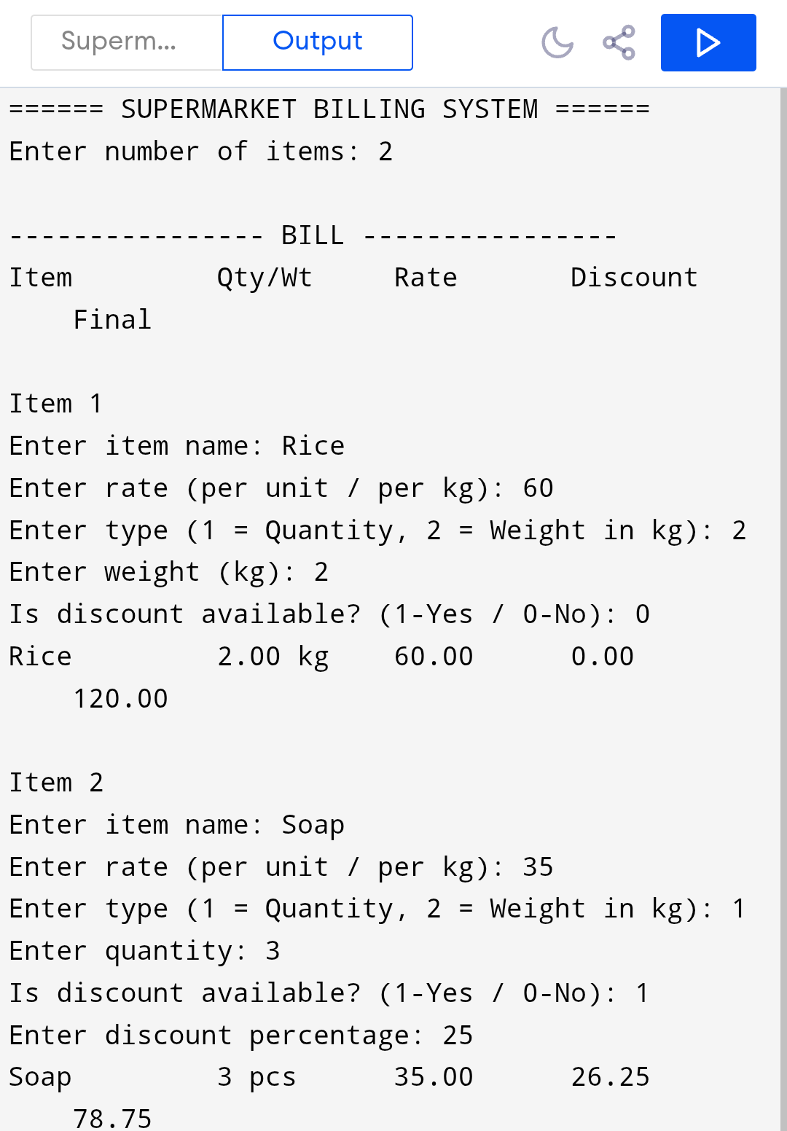
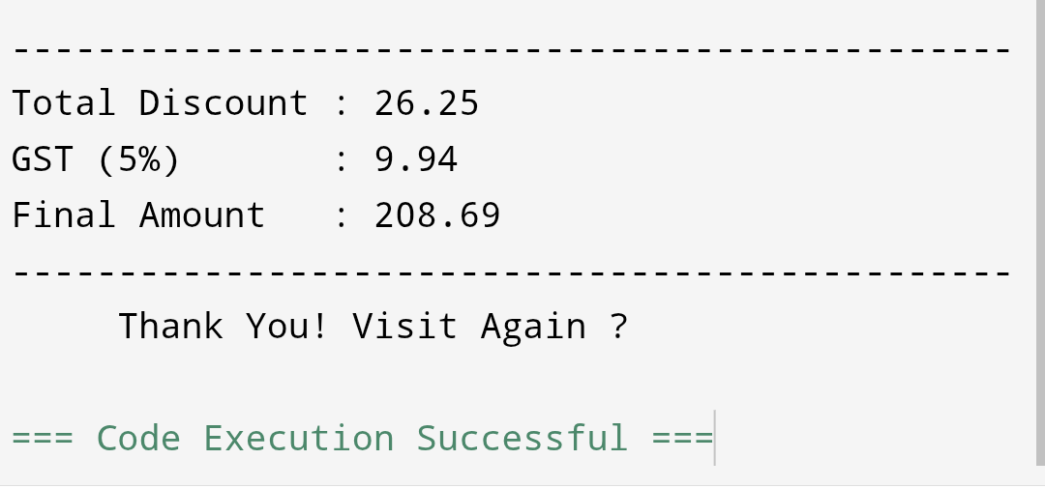

7. DISCUSSION & CONCLUSION

7.1 Discussion
The Supermarket Checkout and Discount Billing System was developed to automate the billing process in supermarkets and retail stores. The system allows users to enter product details such as price and quantity, and it automatically calculates the total bill and applies discounts where applicable.
During the development of this project, various Core Java programming concepts such as variables, loops, conditional statements, and user input handling were implemented. The use of loops helped in handling multiple items efficiently, while conditional statements were used to apply discount logic based on the total bill amount.
The system was tested with different input values to ensure that it performs calculations accurately and handles multiple items correctly. The results obtained from testing show that the system successfully calculates the total amount, applies the correct discount, and generates a clear and structured bill.
The system significantly reduces manual effort and minimizes the chances of calculation errors. It also improves the speed of the billing process, especially during busy hours in supermarkets.
However, the system is currently limited to basic billing operations and does not include advanced features such as database storage, barcode scanning, or graphical user interface. These features can be added in future improvements.

7.2 Conclusion
The Supermarket Checkout and Discount Billing System is a simple and efficient application developed using Java programming. It successfully demonstrates the use of programming concepts in solving real-world problems related to billing systems.
The system automates the billing process, reduces human errors, and provides faster service to customers. It generates accurate bills by calculating totals and applying discounts automatically.
This project helps in understanding how Java can be used to develop practical applications in the retail sector. It also provides a strong foundation for developing more advanced billing and management systems.
In future, the system can be enhanced by adding features such as:
- Database integration for storing transaction records
- Graphical User Interface (GUI) for better user experience
- Barcode scanning for automatic product entry
- Online payment system integration
Overall, the project is successful in achieving its objectives and provides an effective solution for supermarket billing operations.

8. REFERENCES

The following resources were used during the development of this project:
Books
• Herbert Schildt – Java: The Complete Reference
Websites
• https://www.oracle.com/java
• https://www.geeksforgeeks.org
• https://www.w3schools.com
• https://www.javatpoint.com

